|  |  |
| --- | --- |
|  | Foundation Activity 7 Ohm’s Law |

Contents and Learning Outcomes

Students will,

1. Use Ohm’s Law to relate voltage, current, and resistance
2. Calculate the resistor value for a 3.3V LED circuit

Although this activity is intended for a wide range of students (grade 4 and up), students inexperienced with fractions, multiplication, division, and rearranging linear equations should be encouraged to focus on the relationship defined by Ohm’s Law, rather than worry about the exact numbers and calculations.

This activity should take **~1 hour (1.5 hours recommended)** to complete:

Materials and Costs per Student 2

Lesson 2

Activity Overview (2 minutes) 2

Review of the Rock-Slide Analogy of Electricty (5 minutes) 3

Ohm’s Law Examples (10 minutes) 3

Ohm’s Law and the LED Circuit (10 minutes) 4

Choose the Resistor Value and Test the Circuit (10 minutes) 6

Compare Results (10 minutes) 6

Debrief Discussion (5 minutes) 7

Challenge and Explore 8

Frequently Asked Questions 8

Materials and Costs per Student

Assuming one kit of parts per student:

|  |  |  |  |  |
| --- | --- | --- | --- | --- |
| Item | Qty. | Cost per Student1 | Expendable2 | Supplier |
| LED, 5mm, White | 1 | 0.02 | y | AliExpress |
| Resistors, ¼ W, Assorted | 3 | 0.02 | y | AliExpress |
| Jumper cables MM MF FF 10cm | 2 | 0.04 | y | AliExpress |
| Breadboard 400 point | 1 | 1.49 |  | AliExpress |
| Breadboard Power Supply, 5V/3.3V | 1 | 0.75 |  | AliExpress |
| 9V Ni-Mh 450mAh | 1 | 5.17 |  | AliExpress |
| Total Cost per Student |  | **$7.49CAD** |  |  |

1. *Currency is CAD, 2017-06-10. Assuming one set of parts per student.*
2. *Likely to be broken or lost during the activity.*

It is best to have a variety of resistors available for the students to test according to the results of their calculation (even if calculation errors are made). A good variety would include: 1k ohms, 220 ohms, 100 ohms, 22 ohms, 10 ohms, and 1 ohm. Round the student’s calculation results to the nearest available value when giving them the parts to test in the LED circuit.

Each student should also get one printed copy of the activity handout.

Lesson

Before the lesson, change the setting on the breadboard power supply from 5V to 3.3V (usually done by moving a jumper).

For more information, see [SparkFun - Voltage, Current, Resistance, and Ohm's Law](https://learn.sparkfun.com/tutorials/voltage-current-resistance-and-ohms-law)[1]

**Bold text** indicates directions or notes specifically for the instructor.

Activity Overview (2 minutes)

In the last activity we used wire-to-wire soldering to make a voltage-testing LED circuit.

Today, we’re going to:

1. Look at the relationship between voltage, current, and resistance
2. Choose a resistor to match the current needs of our LED circuit
3. Test the resistor value in the LED circuit

Review of the Rock-Slide Analogy of Electricty (5 minutes)

**Draw the rock slide analogy on the board:**

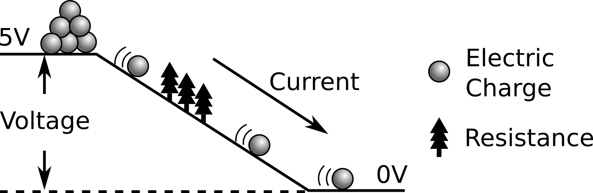

**Ask the students:**

* What happens to current when we increase the voltage? **(draw a higher hill)** A: current increases
* What happens to current when we increase the resistance?**(draw in more trees)**A: current decreases

This relationship between a resistance, the voltage drop across the resistance, and the current through the resistance is described by Ohm’s Law. Which we can write as:

$$Current=\frac{Voltage}{Resistance}$$

This equation matches the observations we made with the rockslide analogy: an increase in voltage causes an increase in current, and an increase in resistance causes a decrease in current.

Ohm’s Law Examples (10 minutes)

Before we try using Ohm’s Law, let’s look at the units used to measure voltage, current, and resistance:

|  |  |  |  |
| --- | --- | --- | --- |
| Rock-slide Symbol | Electrical Property | Unit | Equation Symbol |
| Height of the Hill | Voltage | Volts [V] | V |
| Trees | Resistance | Ohms [Ω] | R |
| Moving Rocks | Current | Amps [A] | I |

As long as we know two of those three, we can find the third using Ohm’s Law! Let’s look at some examples:

**EXAMPLE 1:**

|  |  |
| --- | --- |
| V = 10 V  R = 5 Ω  What is the current, I? | C:\Users\Harryp\MEGA\Surface Pro 2\Nepal\Himalayan Makers Guild\Activities\Foundation Activities\FA7 - Ohm's Law and Resistor Values\images\vir2.png |

**EXAMPLE 2:**

This time, we know I and V, but we don’t know R:

|  |  |
| --- | --- |
| V = 5 V  I = 0.1 A  What is the resistance, R? |  |

To find the R, we need to rearrange Ohm’s Law. To help with this, we can imagine the equation as a triangle **(draw the triangle with the relations on the board).** By covering the variable we’re looking for, the equation using the remaining two variables is left. If they are stacked on top of each other, we divide; if they are side-by-side, we multiply. (V=IR, I =V/R, R=V/I)

|  |  |
| --- | --- |
| C:\Users\Harryp\MEGA\Surface Pro 2\Nepal\Himalayan Makers Guild\Activities\Foundation Activities\FA7 - Ohm's Law and Resistor Values\images\ohms.png | We want to calculate R, so we rearrange the equation to be: $$R=\frac{V}{I}$$ $$R=\frac{V}{I}=\frac{5 V}{0.1 A}=50 Ω$$ |

Ohm’s Law and the LED Circuit (10 minutes)

In our usual LED circuit, we use a resistor to limit the current through the LED. But how much current can the LED handle? Our job is to choose the resistor value: if we put too much resistance we won’t get a very bright light, but if we put too little resistance the current will become too large and burn out the LED.

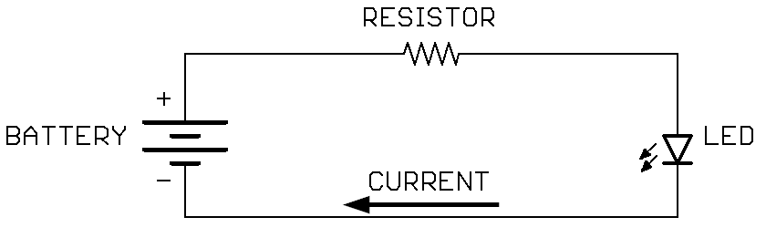

So, what is the most current the LED can take without burning out? Fortunately, the manufacturer of the LED tells the maximum current. For our white 5mm LED it is 20 milliamps.

There are 1000 milliamps in 1 amp. This is just like millimeters and meters for distance.

We know our voltage (5V from the breadboard power supply), so we have two of the three (voltage and current), and we can calculate the Resistance using Ohm’s Law!

|  |  |
| --- | --- |
| However, there’s one more important step! The total voltage from the battery (5V) is dropped across both the resistor AND the LED, since they are wired in series. $$5 V=V_{R}+V_{LED}$$ When the white LED is on, it has a voltage drop of 3V. This leaves only 2V dropping across the resistor. Ohm’s Law relates to the voltage drop across a resistor, so we use the 2V dropped across the resistor when calculating the resistor value. Then, since the resistor and LED are in series, the current through the resistor will be the same as the current through the LED. | C:\Users\Harryp\MEGA\Surface Pro 2\Nepal\Himalayan Makers Guild\Activities\Foundation Activities\FA7 - Ohm's Law and Resistor Values\images\5vLED1.png |

Finally, we can use Ohm’s Law to calculate the optimum resistor value:

|  |  |
| --- | --- |
| C:\Users\Harryp\MEGA\Surface Pro 2\Nepal\Himalayan Makers Guild\Activities\Foundation Activities\FA7 - Ohm's Law and Resistor Values\images\ohms.png | We want to calculate R, so we rearrange the equation to be: $$R=\frac{V}{I}$$ $$R=\frac{V_{R}}{I_{MAX}}=\frac{2 V}{20 mA}=\frac{2 V}{0.02 A}=100 Ω$$ |

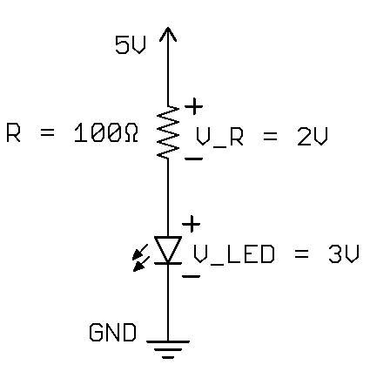

Choose the Resistor Value and Test the Circuit (10 minutes)

Now we are going to build the LED circuit again, but using a 3.3V power supply.

Work in pairs to calculate the new resistor value to make 20 mA flow through the LED. Remember, the voltage across the LED is 3V. When you have calculated the new resistor value, show the instructor and you will get the parts to test the circuit.

Compare Results (10 minutes)

What resistor values did you calculate? How did it work when you built the circuit? How did the brightness of the LED compare to your peers’? Did anyone accidentally burn out an LED by using a resistor that was too small?

Let’s try the calculation together:

|  |  |  |  |
| --- | --- | --- | --- |
| Our supply voltage is 3.3V, and it is dropped across the resistor and LED: $$3.3 V=V_{R}+V_{LED}$$ When the white LED is on, it has a voltage drop of 3V. This leaves only 0.3V dropping across the resistor. | | | C:\Users\Harryp\MEGA\Surface Pro 2\Nepal\Himalayan Makers Guild\Activities\Foundation Activities\FA7 - Ohm's Law and Resistor Values\images\3vLED1.png |
| C:\Users\Harryp\MEGA\Surface Pro 2\Nepal\Himalayan Makers Guild\Activities\Foundation Activities\FA7 - Ohm's Law and Resistor Values\images\ohms.png | We want to calculate R, so we rearrange the equation to be: $$R=\frac{V}{I}$$ $$R=\frac{V_{R}}{I_{MAX}}=\frac{0.3 V}{20 mA}=\frac{0.3 V}{0.02 A}=15 Ω$$ | | | |
| We don’t have a 15 Ω resistor, so the next closest options are 10 Ω and 22 Ω.  Which one should we choose?  A: the 22 Ω one! If we choose a smaller resistance, the current will become bigger than 20 mA and we’ll burn out the LED! | | C:\Users\Harryp\MEGA\Surface Pro 2\Nepal\Himalayan Makers Guild\Activities\Foundation Activities\FA7 - Ohm's Law and Resistor Values\images\3vLED2.png | | |

There are a couple of common errors made when doing the calculation:

1. 3.3V used instead of 0.3V 🡪 165Ω
2. Answer is 1000x smaller than it should be because the student divides by 20instead of 0.02, not accounting for the milliamps unit🡪 0.015 Ω

What is one reason we might want to use a bigger resistor in our LED circuit? A: to make our battery last longer, but the trade-off is having a dimmer LED.

Debrief Discussion (5 minutes)

**Encourage a discussion among the students about their thoughts on the activity.**

Today we used Ohm’s Law to find the ideal resistor value for our LED circuit when powered from 5V or 3.3V. We also saw how the voltage supplied is dropped across the parts in series (shared between the resistor and LED). Why is this important? What applications does this have? Some possible answers include:

* We can now adjust our LED circuit to work with different battery voltages.
* Ohm’s Law describes the relationship between resistance, current through a resistance, and voltage across a resistance. It’s essential for choosing the right components in whatever circuit we’re building.
* When we know the limits of our circuit, or we’re given a certain property that we have to work with, we can use Ohm’s Law to design the circuit to meet those restrictions.

What worked? What didn’t work? Why didn’t it work? What could we do next, or how could we make the circuit better?

Challenge and Explore

**If a student completes the lesson early, evaluate their understanding by asking them to try the following:**

* What resistor value should I choose if I am powering the LED circuit from a 9V battery? A:

|  |  |
| --- | --- |
|  | ***C:\Users\Harryp\MEGA\Surface Pro 2\Nepal\Himalayan Makers Guild\Activities\Foundation Activities\FA7 - Ohm's Law and Resistor Values\images\9vLED1.png*** |

* If we add a 2nd LED in series with the LED and resistor, then power it from a 9V battery, what resistor value should we use then? A:

|  |  |
| --- | --- |
| = 3V | ***C:\Users\Harryp\MEGA\Surface Pro 2\Nepal\Himalayan Makers Guild\Activities\Foundation Activities\FA7 - Ohm's Law and Resistor Values\images\9vLED2.png*** |

* Would the 2-LED circuit work if we replaced the 9V battery with a 5V battery; why or why not? A:

$$V_{R}=9 V-\left(2×3 V\right)=9 V-6 V$$

If we tried to use a 5V battery, the LEDs would not turn on because 5V is below the turn-on voltage of the two LEDs in series (6V).

Frequently Asked Questions

As mentioned in §Compare Results, the most common errors when calculating the resistance value are:

1. The voltage of the battery is used, rather than the voltage dropped across the resistor (e.g. with a 3.3V battery, 3.3V is used to calculate resistance instead of 0.3V giving an incorrect resistance value of 165Ω)
2. The current in milliamps is used, without accounting for that in the final answer, causing the answer to be 1000x smaller than it should (e.g. using the 3.3V battery, the student divides by 20instead of 0.02 giving an incorrect resistance value of 0.015 Ω)

1. 1[*https://learn.sparkfun.com/tutorials/voltage-current-resistance-and-ohms-law*](https://learn.sparkfun.com/tutorials/voltage-current-resistance-and-ohms-law)